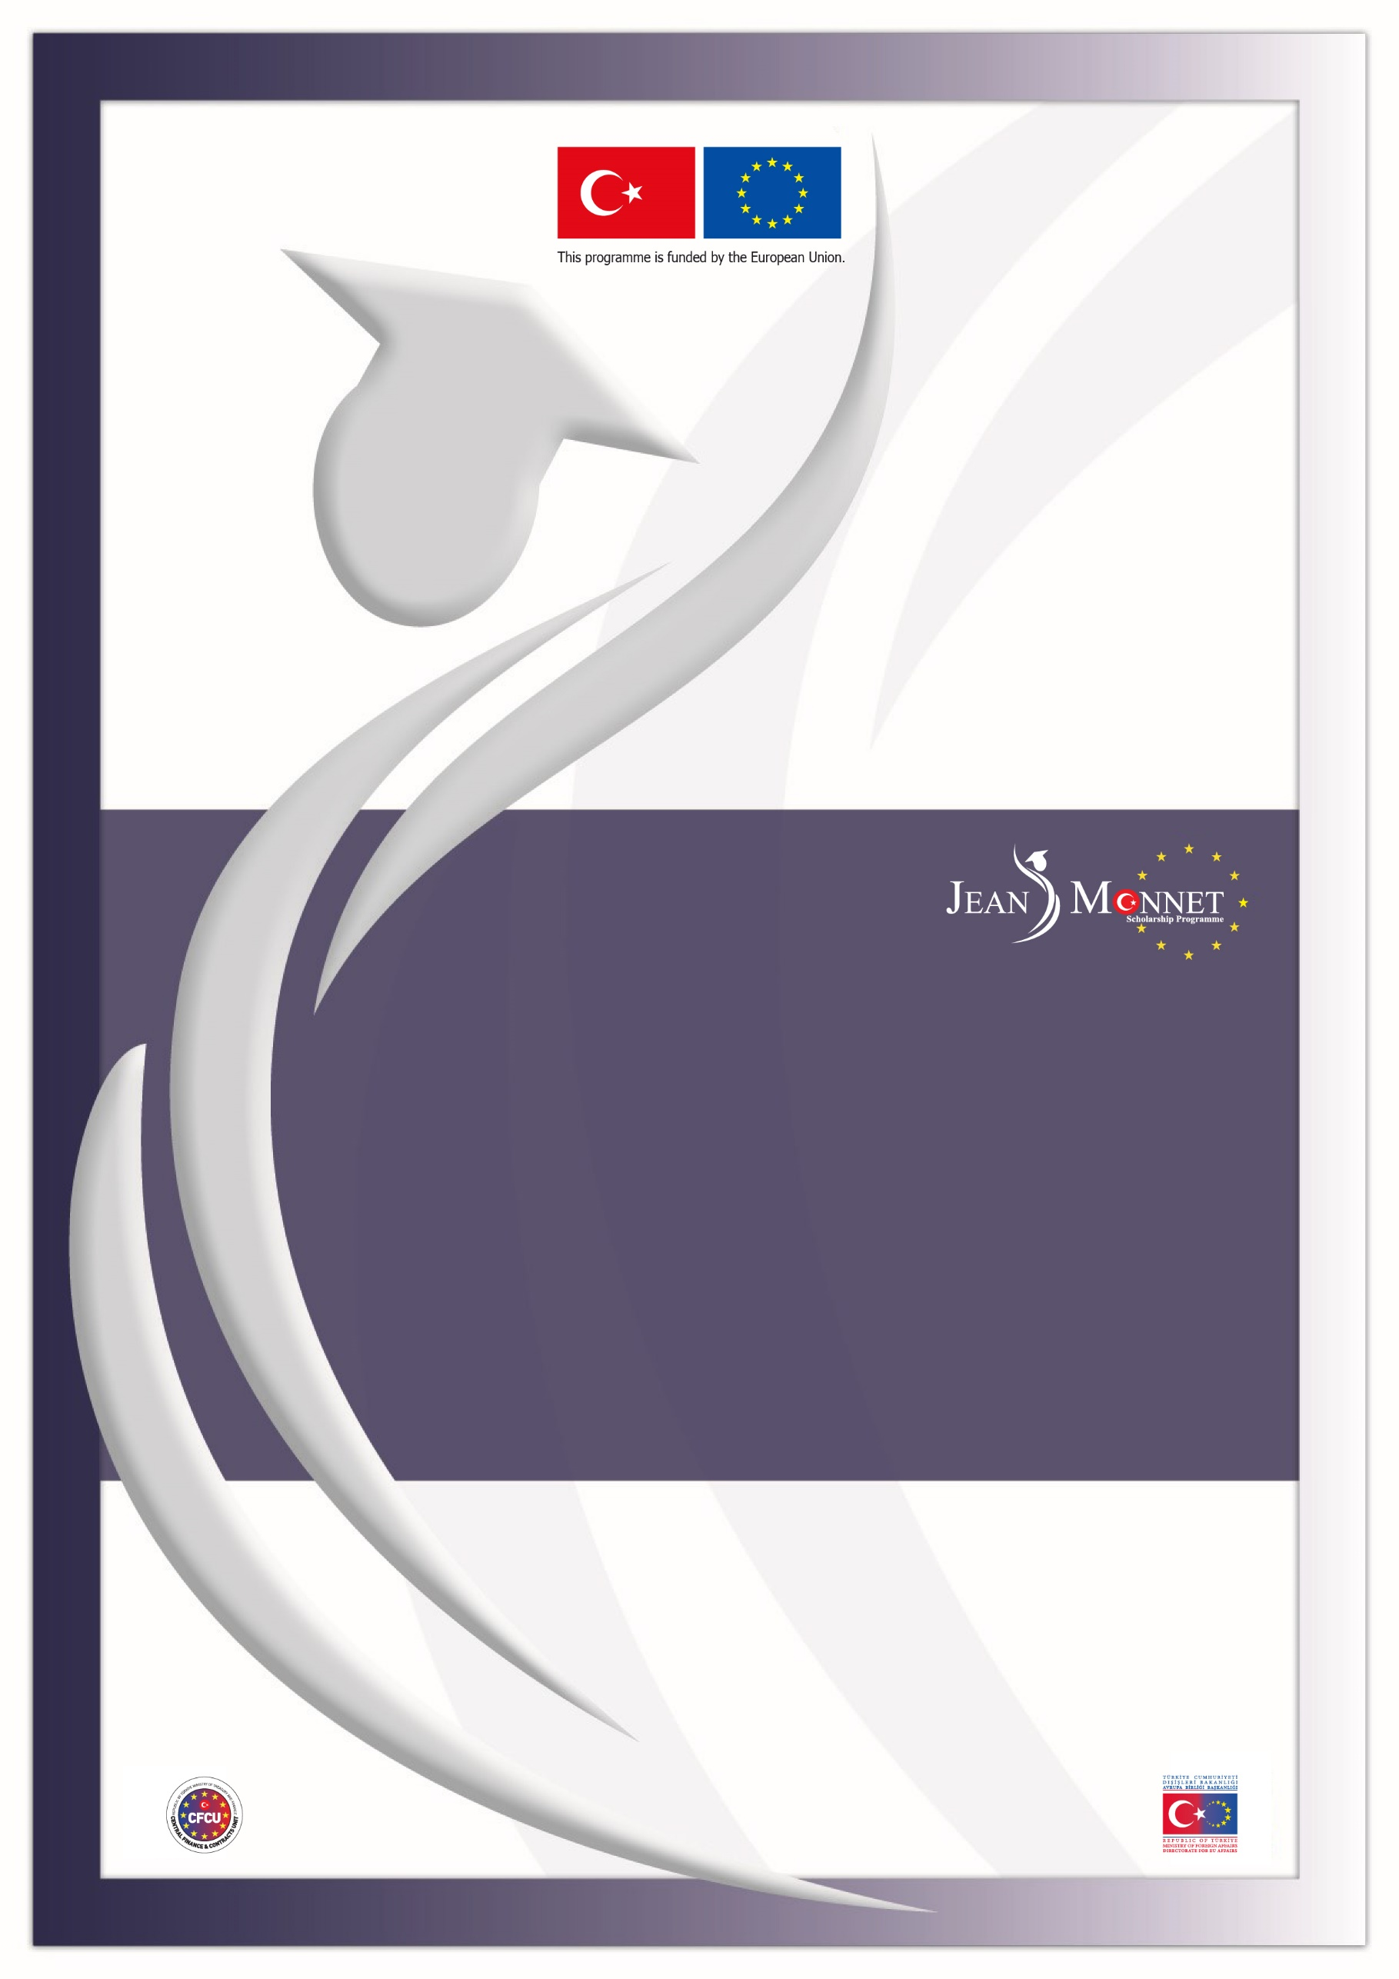

Directorate for EU Affairs Central Finance and Contracts Unit Delegation of the EU to Türkiye

TR2022/W2T2/A03/OT01-1
2024-2025 ACADEMIC YEAR
JEAN MONNET SCHOLARSHIP PROGRAMME
CLARIFICATIONS

IMPORTANT NOTICE
The questions received from potential applicants for the 2024-2025 academic year Jean Monnet Scholarship Programme together with their answers can be seen below. These questions and answers are valid for the 2024-2025 academic year Announcement and the questions and clarifications of the previous academic years do not set a precedent for the mentioned academic year.

Clarifications constitute an essential part of the Announcement; for this reason, the applicants must read the Clarifications document very carefully and pay attention to the details while applying to the scholarship.

Please note that the replies given to the questions on the eligibility are provided solely for the question asked without consideration of whether the other eligibility criteria stated in the Announcement are fulfilled or not.

As stated in Section 2.3.3. Important Notes for Application of the 2024-2025 Academic Year Jean Monnet Scholarship Programme Announcement, questions related to the issues clearly stated in the Announcement document will not be answered in the Clarifications document.

In the interest of equal treatment of applicants, the contracting authority or the Directorate for EU Affairs cannot give prior opinion/approval neither during application nor during evaluation stages, on:
- the acceptability/adequacy of the application documents,
- the sector from which the applicant should make an application,
- the eligibility of the academic programmes to be pursued,
- the relevance of the field of study (i.e. EU acquis chapter) with the academic programmes planned to be pursued.
LANGUAGE PROFICIENCY CERTIFICATES
1 | Q: Should I take PTE Academic at test centre or online (at-home version)?  C: Both are acceptable for application to the Scholarship Programme.
2 | Q: Should I take IELTS Academic on computer or paper or online?  C: All are acceptable for application to the Scholarship Programme.
3 | Q: Is the IELTS requirement minimum 6.5 overall score or minimum 6.5 for each of the modules such as speaking, reading, etc.?  C: Overall score will be taken into consideration.
FIELD OF STUDY
4 | Q: Can I select any field of study when applying? Or does it have to be related to the field I am currently working/pursuing study in?  C: The Jean Monnet Scholarship Programme considers the compliance of the study field selected with the field of the academic programme to be pursued as well as compliance with the objective of the scholarship. In this manner, the Scholarship Programme does not take into consideration the compliance of the selected academic programme with the academic or professional background of the applicant.
SECTOR
5 | Q: I have graduated from an undergraduate/graduate programme. However, I neither started to work, nor am I registered to a master’s degree/PhD programme. May I apply?  C: No. In order to be eligible, applicants should either be working in Türkiye on a professional basis (i.e. under a social security network, in return for a wage) in public sector or private sector or university sector as academic/administrative staff or be senior undergraduate students/ master’s/PhD students in the universities in Türkiye.
6 | Q: I am currently a senior undergraduate student and will graduate in January-February 2024. Looking at the application criteria it appears I am eligible to apply. However, during the written exam and at the time the scholarships are granted I will be unemployed. May I still benefit from the scholarship to pursue graduate study/research?  C: Yes. As long as applicants are registered as senior undergraduate students at the time of application, having graduated and being unemployed in the following stages does not form a problem. Please also note that awardees who were senior undergraduate students while applying to this Announcement, should submit a Graduation Certificate/Diploma related to their undergraduate programme before contract signature.
7 | Q: Due to insufficient credits, I will appear as a 3rd year student in my transcript document at the time of application. However, I will be a final year student in spring term and graduate in 2023-2024 academic year. May I apply?  C: Although prior opinion/approval cannot be given on the adequacy of the application documents, it is recommended to submit supporting documents (preferably taken from the university) explaining this situation. Please also see Answer-6.
8 | Q: To which date do we still need to be working/employed? Is it sufficient to be working until the application deadline?  C: Those who apply as employees from the “public” or “private sector” or as academic or administrative staff from the “university sector” should still be working in the sector they applied from once they are notified that they have been recommended for award of a scholarship and will be requested to submit relevant supporting documents. In case an applicant fails to submit the requested documents until the given deadline, they will not be allowed to continue the contracting process and will be deemed to be withdrawn from the scholarship.
9 | Q: If I change my job/workplace after the application but still work in the same sector, do I need to inform Central Finance and Contract Units or provide any document indicating this update?  C: No. Please also see Answer-8.
10 | Q: I am currently working in the private sector; however, I am also registered as an undergraduate/graduate student. Would this be a problem if I apply from the private sector?  C: Those who meet the required criteria and who can submit the required documents of the private sector may apply.
11 | Q: Although I am residing in Türkiye, I am working for a foreign company and paying my own social insurance premiums and taxes. For applicants working in the private sector is it essential for the employer company to be in Türkiye?  C: Prior opinion/approval cannot be given for the eligibility of an applicant. In order to be eligible, the applicants should be working in private sector “in Türkiye” (including the employees of resident diplomatic missions, Non-Governmental Organisations, etc.) and submit all the relevant documents specified in the Announcement. Please also see section 2.1 of the Announcement for further details.
12 | Q: Will it present a problem if the employment document from the private sector indicates fixed term contract employment (such as for a period of 3 months)?  C: No. On the other hand, please note that those who applied from the private sector should still be working in the sector they applied from once they are notified that they have been recommended for award of a scholarship.
13 | Q: I am currently a PhD student; can I apply to the Jean Monnet Scholarship Programme for a graduate study?  C: Yes, as long as you fulfil the eligibility criteria stated in the Announcement, you may apply.
14 | Q: I am a graduate student. Do I have to apply at the thesis stage (final year) of my study or may I apply while taking courses?  C: You may apply at any stage of your graduate programme.
15 | Q: I am enrolled to a distance learning graduate programme without dissertation in Türkiye. May I apply from university sector?  C: Yes. Students who are enrolled to a distance learning graduate programme in a university in Türkiye with or without a dissertation may apply.
CGPA
16 | Q: Is there a requirement regarding duration of work experience when applying for a scholarship?  C: Minimum 36-month work experience or a graduate degree is only required from the applicants whose CGPA is less than 2.70/4.00 or 70/100. Otherwise, there is no minimum work experience requirement for application.
17 | Q: My CGPA is under 2.70/4.00, therefore I will apply on the condition of 36-month work experience. However, part of my work experience is in the private sector and part in the public sector. Does all 36- month work experience have to be in the same sector?  C: No, 36-month work experience does not necessarily have to be in the same sector. Those who have a CGPA less than 2.70/4.00 or 70/100 may apply only on the condition that they have at least 36-month work experience or have completed a graduate programme (master’s or PhD).
18 | Q: Is it sufficient if the 36-month work experience is fulfilled on the day the application is submitted or should 36 months have been completed on 7 September 2023 when the applications announcement was published?  C: 36-month work experience will be calculated based on the documents submitted by the applicants. Therefore, the day on which the application is submitted will be taken into account.
TRANSCRIPTS AND GRADUATION DOCUMENTS
19 | Q: As a senior undergraduate student, I took courses abroad within the Erasmus Programme last term, which is not yet reflected in my signed official university transcript. Can I apply?  C: Prior opinion/approval cannot be given on the adequacy of the application documents. However, you are recommended to submit supporting documents (preferably taken from the university) explaining your situation.
EMPLOYMENT DOCUMENTS
20 | Q: Does the payroll, employment document or consent letter from the employer institution of a private sector applicant have to be translated to English or are the Turkish documents accepted?  C: Documents prepared by the employer in Turkish or in English are accepted.
21 | Q: How many months payroll should be submitted at application?  C: One-month payroll which meets the criteria indicated in the Announcement is sufficient for application.
INTERNS
22 | Q: Based on the amendment of the Attorneyship Law, being employed under a social security system will not form a barrier to pursue legal internship as long as it does not present a factual obstacle to the internship. May I apply for a scholarship if I work in the public or private sector under social security during my internship period?  C: Yes.
HOST INSTITUTIONS AND OFFER LETTERS
23 | Q: Can we pursue study at the campus of a British university located in an EU member country?  C: Yes. According to the Scholarship Programme rules, scholars may pursue study in the EU member countries regardless of the origin of the university.
24 | Q: Can we apply for a one-year programme jointly run in multiple EU member countries?  C: Yes. Study programmes to be pursued in multiple EU member countries may be evaluated on condition that the offer letter submitted at the placement stage clearly indicates the timescale within each of the host countries.
25 | Q: What is the format of the offer letter for research programmes? Is it an invitation letter from the academic advisor? Should we find the professor, determine the project topic and then submit for approval?  C: The offer letter should specifically contain the name of the award holder, start and end dates of the research programme, topic of the research, as well as the name of the academic advisor with whom the research will be conducted. It may be issued either by the university or academic advisor. It is the scholars' responsibility to contact the universities.
26 | Q: Can we pursue a programme without dissertation if we are awarded a Jean Monnet scholarship?  C: Yes. Programmes with dissertation is not obligatory within the Jean Monnet Scholarship Programme.
27 | Q: Should I mention that I am applying for a Jean Monnet scholarship when applying to schools?  C: It is the applicant’s choice whether to mention s/he has also applied for a Jean Monnet scholarship or not.
TUITION FEES
28 | Q: Is the tuition fee still fully covered within the joint project between the Jean Monnet Scholarship Programme and Queen Mary University Paris Campus?  C: There are no joint projects where tuition fees are fully covered. However, some universities offer discounts at different rates to Jean Monnet scholars. It is recommended to contact the host institutions regarding discounts.
29 | Q: Universities may request deposit payments when issuing offer letters. Are we responsible for making these payments?  C: Yes. It is solely the applicants’ responsibility to identify the suitable academic programmes in line with their field of study and to obtain offer letter(s) from the academic programmes. On the other hand, the risk of the study programme for which a deposit has been paid not being approved should be noted, as the Directorate for EU Affairs retains the right to give the final decision on the programme approvals to ensure the compliance of the programmes with the fields of study (EU acquis chapters) and the optimal exploitation of the scholarships.
BREXIT
30 | Q: Is the UK an eligible host country for the 2024-2025 academic year?  C: No.
31 | Q: I completed a graduate degree funded by the United Kingdom (e.g. Chevening, GREAT, etc), can I apply for a Jean Monnet scholarship?  C: Yes.
OTHER
32 | Q: What is the process to be followed if there is change of name/surname while the evaluation process continues?  C: Applicants whose name/surname changes after the application documents are submitted should inform the Central Finance and Contracts Unit and submit the official supporting document, such as court order, marriage certificate, etc..
33 | Q: Can a public sector employee take unpaid leave or is secondment essential?  C: The applicant must submit relevant supporting document proving that s/he is working in the same sector before contract signature. The issue of how employees will be assigned or leave issue is at the discretion and authorisation of the institutions/organisations that they are affiliated to.
34 | Q: Does Jean Monnet Scholarship Programme support pre-master study?  C: No.
35 | Q: Can scholars take their families with them to the host country?  C: Being accompanied by family members is at the discretion of scholars. However, it should be noted that the Jean Monnet Scholarship only covers the expenses of the scholars. No extra allowance is paid to the scholars who will be travelling with their families/personal attendants.
36 | Q: Can we send an additional document after we have submitted our application?  C: It is solely the applicant’s responsibility to submit the application documents in a complete form to the Central Finance and Contracts Unit until the application deadline. If need arises to send any document after the submission of the application (no later than the application deadline), a petition letter explaining the situation in detail should also be attached to the document.
37 | Q: Would it be a problem if we take up employment within the host country or distance work for a company in Türkiye during the duration of our scholarship?  C: Issues regarding work are not within the context of the Scholarship Programme. However, please note that scholars are expected to successfully complete their academic studies and fulfil their contractual obligations within the Jean Monnet Scholarship Programme. The scholars who could not successfully complete their academic studies or who could not fulfil their contractual obligations will be requested to pay back the whole or a partial amount of the scholarship they have been paid.
38 | Q: What should we write in section "X" in the Application Form?  C: You should fill in the Application Form with statements which truly reflect your current situation and which are consistent with the other supporting documents you have submitted.
39 | Q: I realised that I had not written the statement “Not To be Opened Before Opening Session” when I sent my application documents. Should I re-send the documents with the statement as indicated in the announcement or would it be accepted as it is?  C: No, you do not have to re-submit your application if it is already received and registered by the Central Finance and Contracts Unit.
40 | Q: The latest Jean Monnet Academic Year Report published is the 2015-2016 report and no reports have been published since. Can you please share the reports?  C: No. Based on the General Data Protection Regulation, Academic Year Reports are not publicly published.
41 | Q: Which days and hours is Central Finance and Contracts Unit open for us to submit our applications?  C: Central Finance and Contracts Unit offices are open on workdays between 09:00-18:00 hours.
42 | Q: During my master's degree in Italy, I received scholarship funding by the Lazio region (Lazio DiSCo), but this support was 420 Euros per month, which did not cover tuition fees, did not cover expenses such as travelling to conferences, and did not include fees such as health insurance, whereas scholarships such as DAAD, EIFELL are much more comprehensive. Is there a list indicating which scholarship holders cannot apply for this scholarship?  C: Prior opinion/approval cannot be given for the eligibility of an applicant. Assessment will be done based on the submitted application documents. There is no list indicating which scholarship holders cannot apply for this scholarship.

